1

1. ρ=xcosθ+ysinθ

x and y constant

ρ=xcosθ+ysinθ

=(x^2+y^2)^(1/2)sin(θ+α)

where sinα=x/((x^2+y^2)^(1/2)), cosα=y/((x^2+y^2)^(1/2))

so it's sinusoidal with amplitude=(x^2+y^2)^(1/2), phase=α

2. maximum absolute value of ρ : (W^2+H^2)^(1/2)

if ρ is always positive, 0≤θ≤2𝜋

2

1.



2.

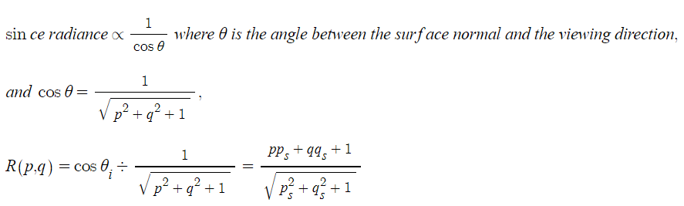

3

the problem is to minimize p^TA^TAp where p^Tp=1

the Lagrangian is p^TA^TAp-λ(p^Tp-1)

derivative with regard to p should be equal to zero. A^TAp-λp=0

this means p should be eigenvectors of A^TA with eigenvalue λ.

this gives the Lagrangian equals to λ.

by minimizing λ, ||Ap|| is also minimized

since columns of V in SVD of A corresponds to the eigenvectors of A^TA

p should be the column of V which corresponds to the smallest eigenvalue of A^-TA.

4

non maximum suppression on edges



firstly, determine how long the suppression should be done

then pad 0s around due to the same reason as the padding in the convolution

then get the maximum value in perpendicular direction to edges

and check if it is the same with current value

if not, the current value as 0



for interpolation, the comparision is made with iteration

using the distance between the two adjacent values, weight each value differently



before nms it looks like this.

after nms,

the edge is more clear as below.



the grayscale image of Im is as above.



the grayscale image of H is as above.



this is a part of H.

for other pictures, see below.













I set the parameters as follows.

sigma : 1, threshold : 0.2, rhoRes : 1, thetaRes : pi/270, nLines : 15

In H, I implemeneted nms as follows. Firstly, pad zeros around and then check values x in [x-k, x+k] and y in [y-k,y+k]

if the max value is not the current one, set current one as 0

resolutions are needed since, in program, rho and theta values should be made from the index of H.

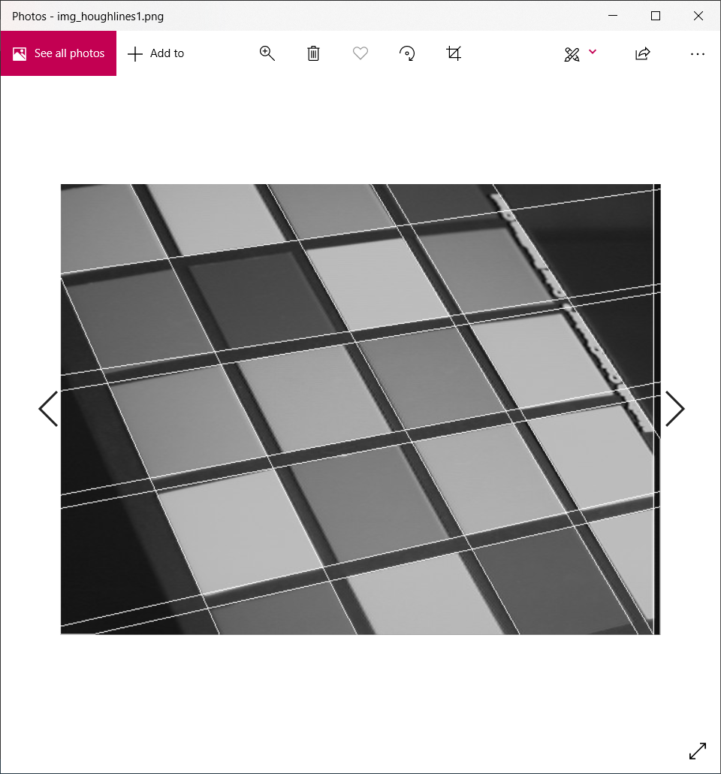

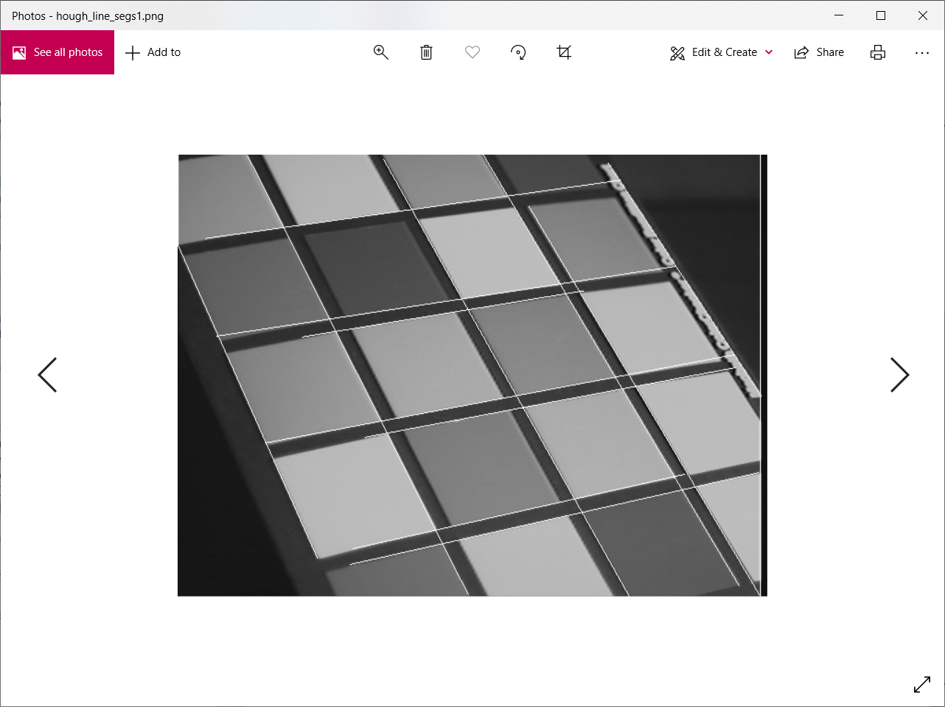

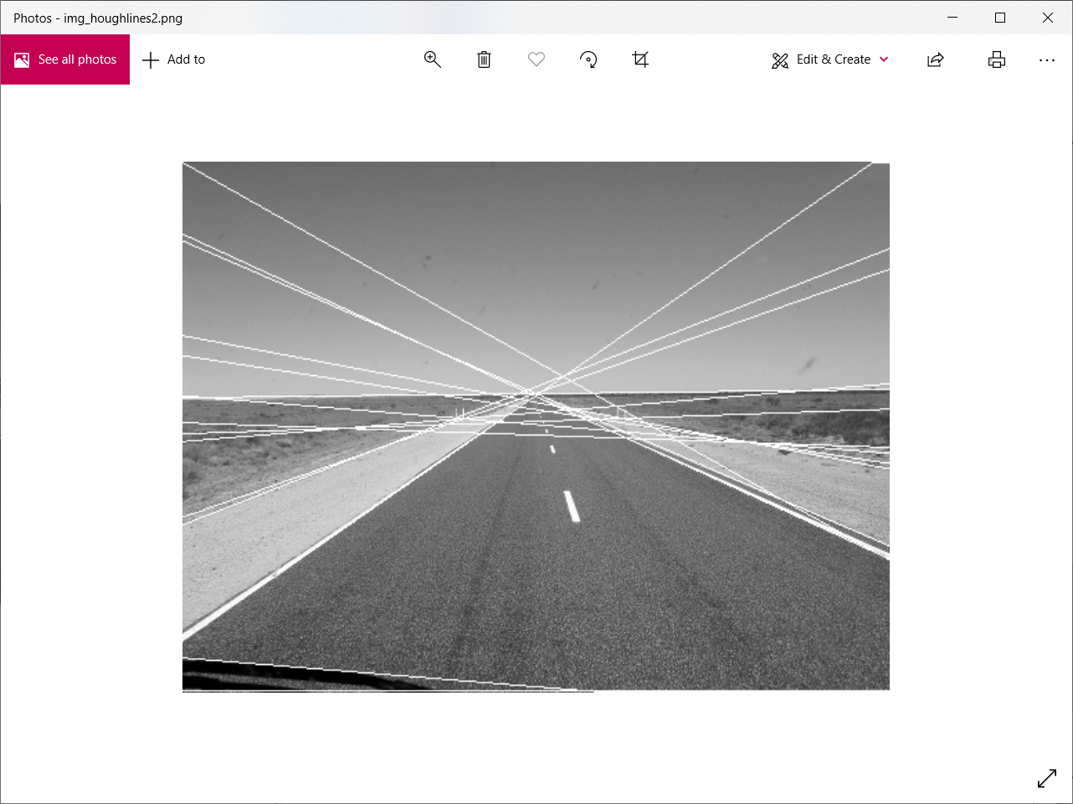

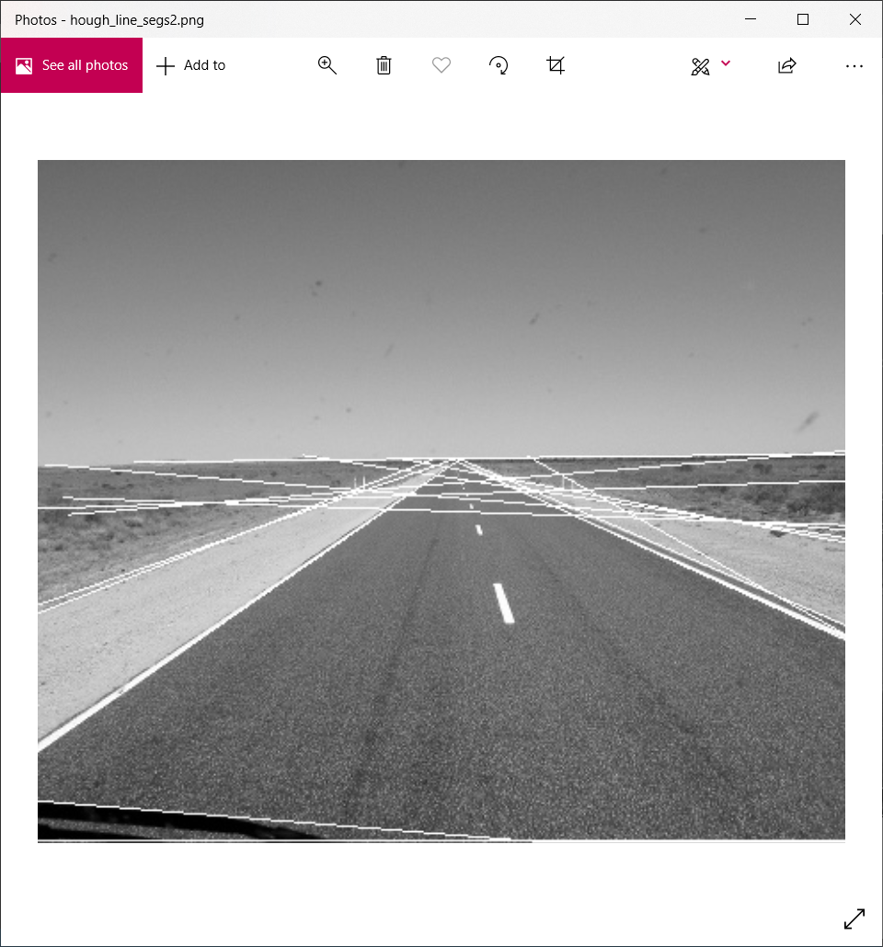

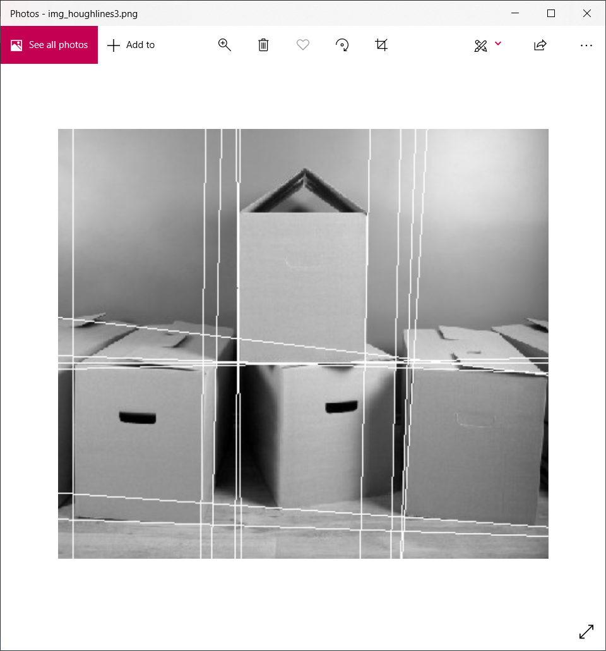

for the last picture

I needed to change parameters as follows

sigma=1.5

threshold=0.4

rhoRes=2

thetaRes=math.pi/90

nLines=25

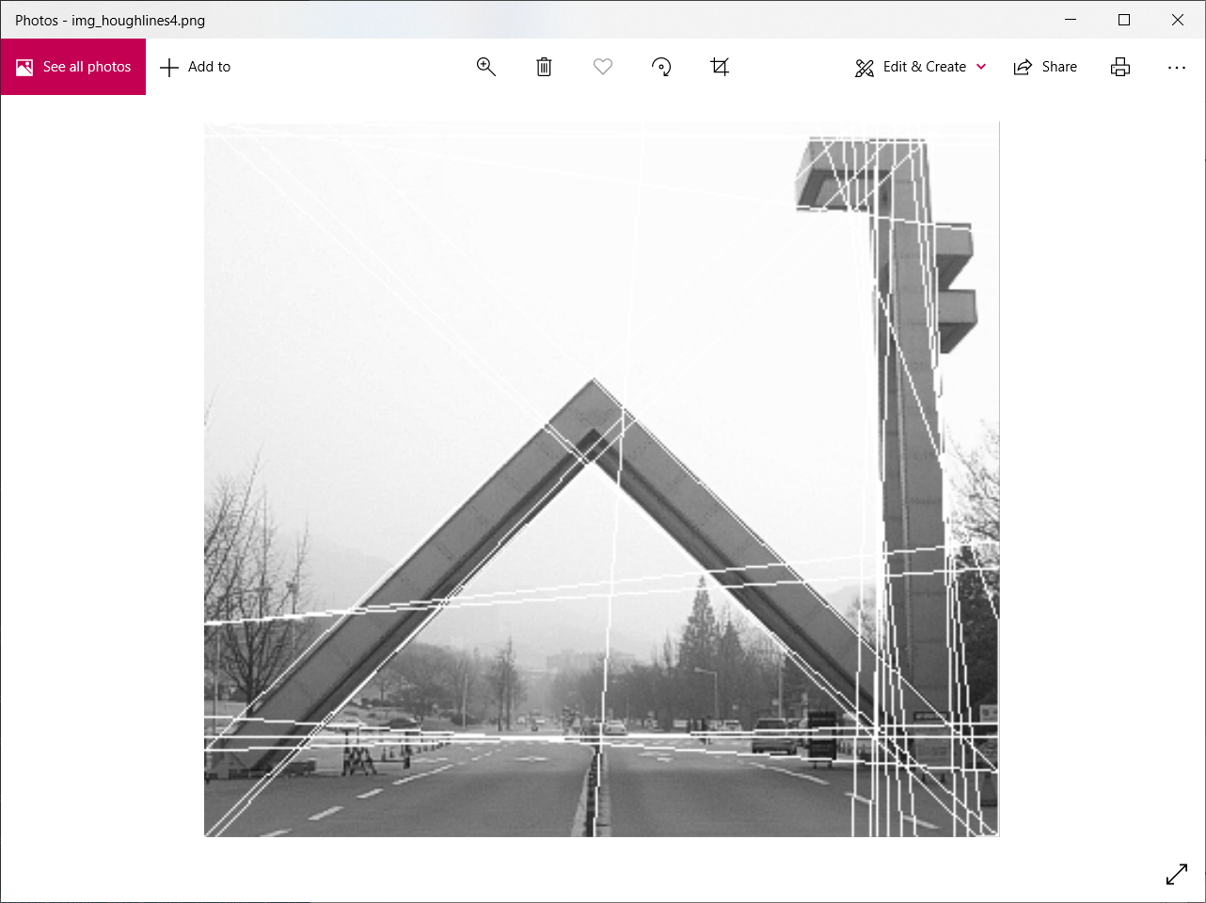

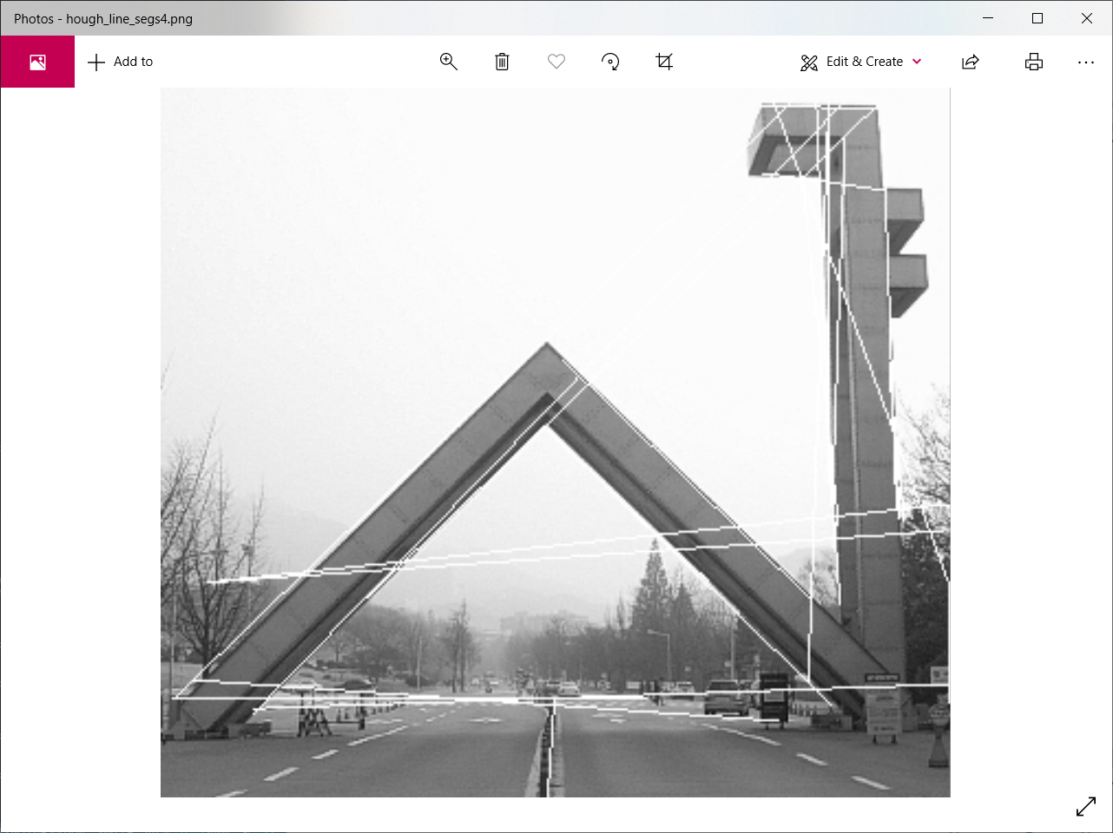

these files are stored in the same directory where the code is located.